Docmee
Architecture & Technical Documentation
AI chatbot platform for medical clinics — central multi-tenant SaaS
Harmonized across the architecture spec and design document (A1–A24)

Contents

1. Overview
Each clinic gets an AI bot that answers patient questions from a clinic-specific knowledge base, books appointments via Google Calendar, and hands off to human secretaries when needed. Docmee runs as one central, multi-tenant platform with an IA Studio admin layer; a self-hosted, license-controlled deployment is reserved as a future commercial mode.
- Operating model: central SaaS, multi-tenant, strict per-clinic isolation.
- Channels: WhatsApp at launch; Messenger + Instagram in Rollout 2B.
- Control: three runtime gates — platform flag → plan → clinic toggle.
- Guiding rule: soft enforcement — limits block new growth, never a live clinic.

2. System architecture
A layered architecture: people at the edge, a thin API/edge tier, an asynchronous processing core, the intelligence (agent) layer, and the data + integrations tier.
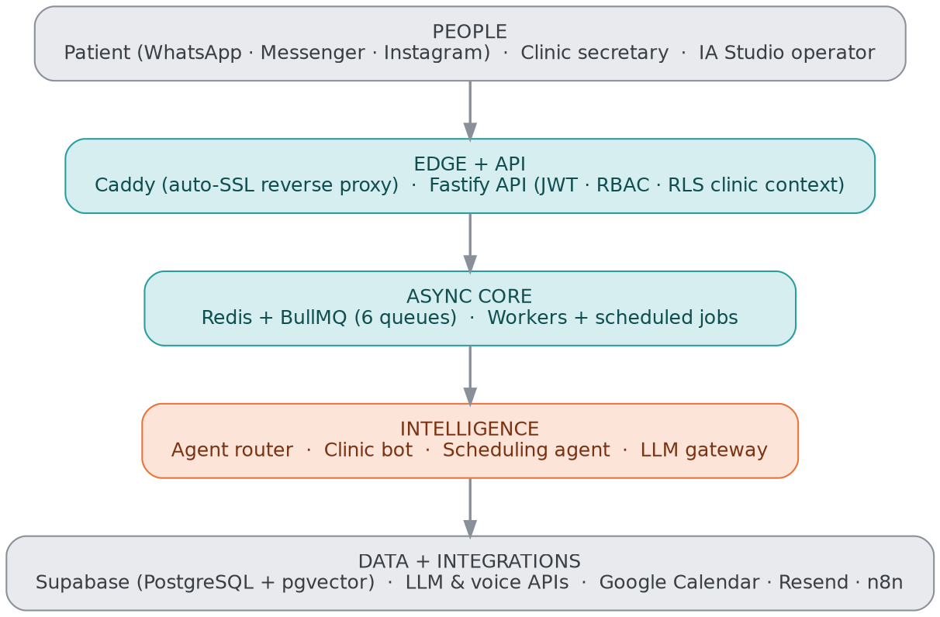
Figure 1 — Layered system architecture
The whole stack ships together (pnpm monorepo) behind one Caddy front door. The load-bearing separation is at the data tier: patient-facing generation routes to Claude, intent classification to DeepSeek only, embeddings to OpenAI.

3. Runtime data flow
How a patient message travels in and out. The 200 OK to Meta is returned before any processing; the bot-interruption check is the first operation in the conversation processor.
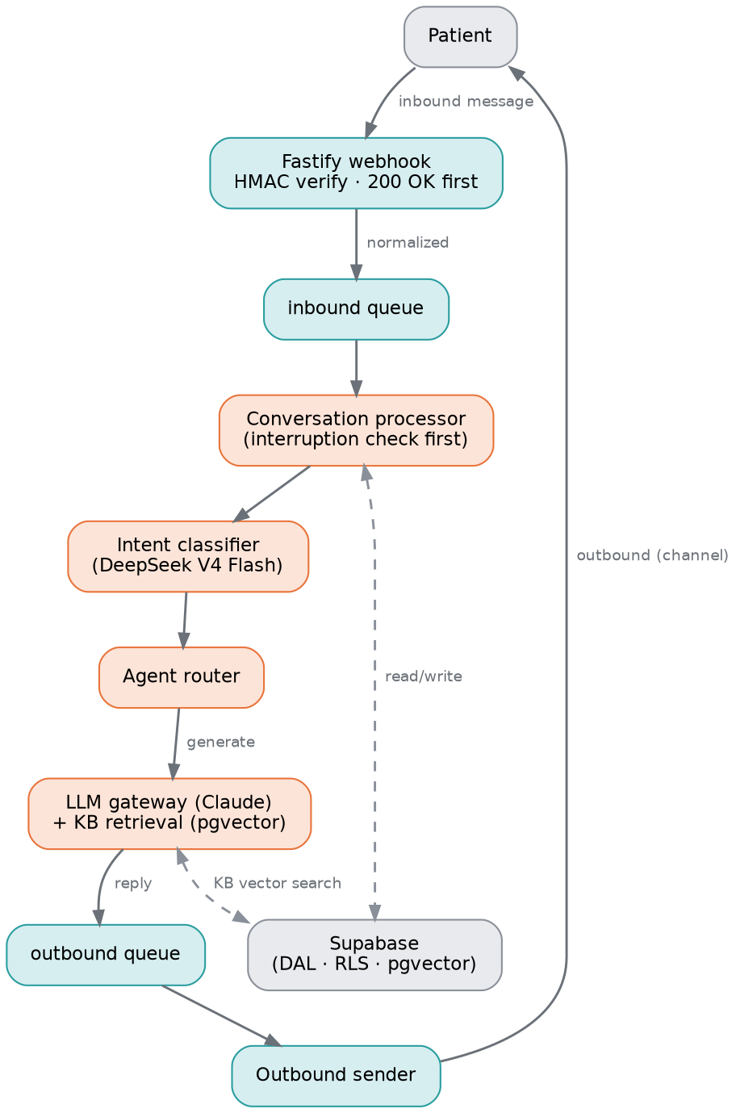
Figure 2 — Runtime message data flow (inbound to outbound)

4. Agent layer
The intent classifier routes each message; the clinic bot answers from the knowledge base, the scheduling agent books appointments, or the conversation escalates to a human. Escalation is terminal — a secretary takes over and the bot stops auto-replying.
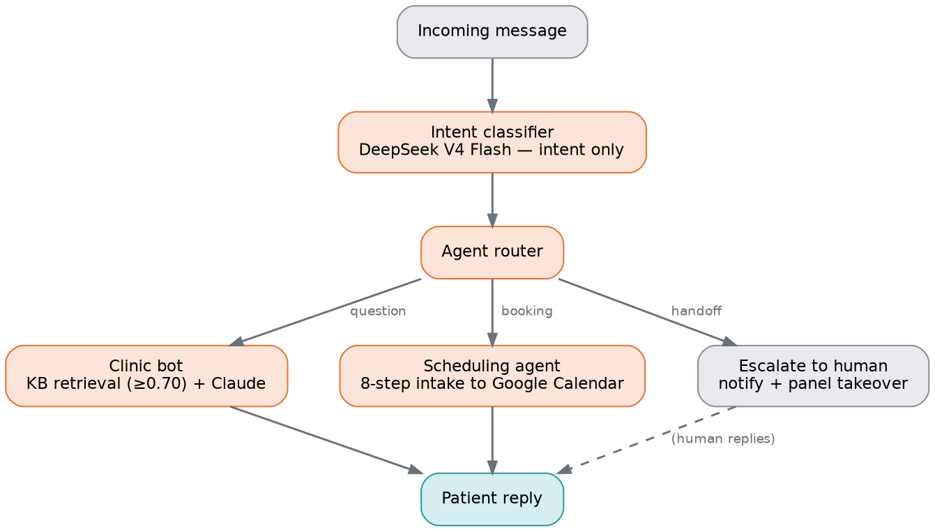
Figure 3 — Agent orchestration
- KB grounding only: below similarity 0.70 the bot does not fall back to general LLM knowledge — it acknowledges the gap and offers handoff. The “rules” KB category is injected into every system prompt in full.
- Intake state machine: stored in the DB, survives mode switches; multi-doctor aware (routing by doctor/specialty, per-doctor KB and optional tone).
- Calendar is the source of truth for appointment datetime; Docmee DB is the source of truth for everything else.

5. Data model
Forward-only, additive migrations. Every clinic-scoped table carries clinic_id with RLS: USING (clinic_id = current_setting('app.clinic_id')::UUID).
Domain | Tables
Tenancy & people | clinics · clinic_users · doctors · user_sessions · auth_events
Patients | patients · patient_intake · patient_notes · patient_tags · patient_consent
Conversations | conversations · messages · conversation_notes
Scheduling | appointments · appointment_status_log
Knowledge base | kb_entries (vector) · kb_entry_versions · kb_embedding_jobs · kb_improvement_suggestions
Channels & templates | meta_templates
Automation | automation_rules · automation_queue
Metrics & quality | clinic_metrics · error_log · report_schedules
Notifications | notification_preferences · push_subscriptions
Integrations | clinic_integrations · integration_events · document_uploads
Billing & control | plans · plan_addons · clinic_subscriptions · subscription_usage · invoices · platform_feature_flags
Governance | audit_log (append-only) · retention_policies

Encrypted fields (pgcrypto): patients.phone, patients.channel_id, patient_intake.reason, patient_intake.special_notes, messages.content (inbound), and clinic tokens (Meta, Google). Access is via the Data Access Layer (DAL) — no ORM; agents never hold DB credentials; agent writes are field-level, validated, logged before execution, and never deletes.

6. Roles & permissions
Resource | IA Admin | Clinic Admin | Secretary | Doctor | Assistant
Conversations | RW | RW | RW | R | R (no reply)
Appointments | RW | RW | RW | R | R
Patient data | RW | RW | RW | R | R
Internal notes | RW | RW | RW | R | —
Knowledge base | RW | RW | — | — | —
Clinic settings | RW | RW | — | — | —
User management | RW | RW | — | — | —
Reports/metrics | RW | R | — | R | —
Bot mode control | RW | RW | RW | — | —
Error review | RW | R | — | — | —

7. Control model & soft enforcement
A feature is available only if all three runtime gates pass. A fourth license gate is reserved for the future commercial mode and is not in the active path.
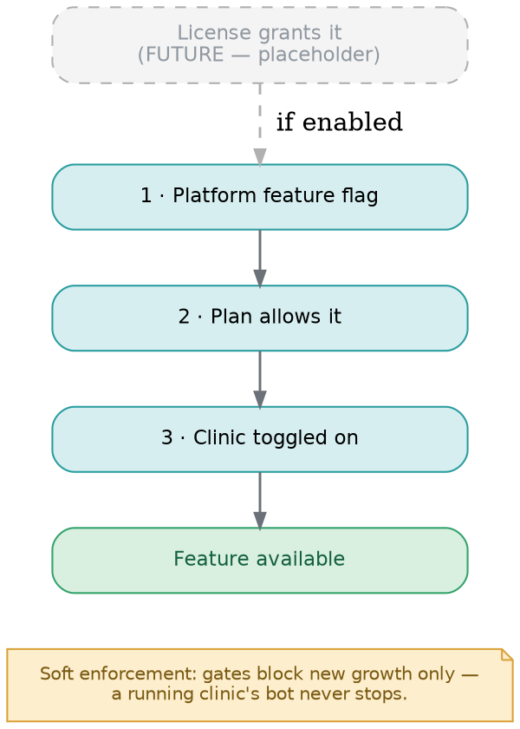
Figure 4 — Feature gating (three active gates; license gate reserved)
Soft enforcement (absolute): quotas, limits, and flags block only new growth (new clinics, seats, feature activation). They must never interrupt a live clinic's messaging. The patient never sees a system error; every error has a defined outcome; security errors are never retried.

8. Channels
WhatsApp at launch; Facebook Messenger and Instagram Direct in Rollout 2B. One WABA + phone number per clinic (clinics cannot share a number). HMAC validation is timing-safe; System User tokens for production. All channels normalize to one internal message schema with: clinic_id, channel (whatsapp|messenger|instagram), patient_identifier, message_type (text|audio|image|template), content, timestamp, and raw_payload.

9. Automation & follow-up engine
A fixed catalog of automations (booking confirmation, 1-day and same-day reminders, post-consultation, 7-day follow-up, 3-month check-in, review request, no-response, abandoned-booking recovery, clinic-no-reply). Every automation passes six gates before it fires.
Figure 5 — The six gates before any automation fires
Cancellation cascades to all pending automations for an appointment. An auto-completion job runs every 30 minutes, marking appointments complete 30+ minutes after end time and triggering post-visit automations.

10. Integrations & n8n bridge
Philosophy: Docmee is the source of communication data; external tools are the destination. Data flows outward; no inbound sync.
- Google Sheets export (lead/appointment fields on trigger events) — via the integrations Google client.
- CRM webhook — POST to a configured URL, HMAC-SHA256 signed, 3 retries with backoff.
- n8n bridge (workflow customization) — clinics build arbitrary workflows visually in n8n. Docmee exposes event triggers (the CRM webhook surface) and a small gated action API (send-templated-message, add-note, tag-patient, schedule). n8n orchestrates but cannot bypass the six automation gates, the Meta-approved-template rule, clinic isolation, or opt-out. It is a bridge, not a native in-panel builder.
- Review platform — link-only; the review-request automation sends the configured URL.
All integration credentials are write-only after initial save.

11. Notifications
Priority | Meaning | Channels
P1 | Emergency, human requested, patient upset — cannot be disabled | panel + email + push
P2 | Bot failed, appointment needed, no-response; high-intent leads upgrade P3→P2 | panel + email
P3 | New lead, confirmation, audio | panel
P4 | Daily digest | email

Escalation chain for unacknowledged urgent alerts: 10 min → assigned secretary · 20 → all secretaries · 30 → clinic admin · 60 → IA Studio admin. Deduplication: same type + same conversation within 5 minutes is suppressed. Quiet hours apply to P3/P4 only. Email via Resend.

12. Queues & workers
Six queues: inbound, outbound, transcription, followup, notification, dead-letter.
Workers: one consumer per active queue (inbound/conversation processor, outbound sender, transcription, followup/automation, notification, DLQ drain).
Scheduled jobs: appointment auto-completion (every 30 min), metrics pre-aggregation, report schedules. Retry policies per queue; failures route to the dead-letter queue.

13. Billing & IA Studio control
Plan | Price | Conversations | Channels | Users | Doctors
Starter | $99/mo | 500 | WhatsApp | 2 | 1
Growth | $199/mo | 1,500 | WhatsApp | 5 | 1
Professional | $349/mo | 3,000 | All 3 | 10 | 3
Clinic Plus | $549/mo | 6,000 | All 3 | 20 | 10
Enterprise | Custom | Unlimited | All | Unlimited | Unlimited

Add-ons: channel +$29 · doctor +$19 · priority support +$49 · 500 conversations +$45. Trial: 14 days on Growth. Usage: one conversation per period at creation; alert at 80%; overage per plan rate. Invoicing: manual by IA Studio → Stripe later.
IA Studio: platform feature flags (all clinics / by plan / by clinic ID, runtime); impersonation (read-only default, 30-min max, fully logged). Clinic deactivation: pause bot → cancel pending automations → revoke sessions → status inactive → subscription cancelled → alert admin → audit log.

14. Deployment & operating model
Central, multi-tenant SaaS. Many clinic tenants share one Docmee platform; per-clinic isolation is enforced by RLS in the database. A self-hosted, licensed install is a documented future mode.
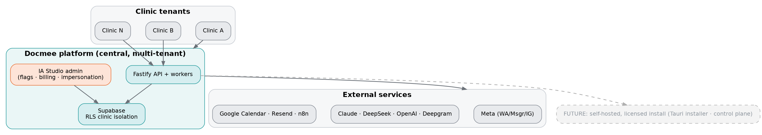
Figure 6 — Central multi-tenant SaaS topology

15. Technology stack (locked decisions)
Decision | Choice
Package manager | pnpm workspaces (monorepo)
API framework | Fastify 4+
Database | Supabase (PostgreSQL + pgvector), us-east-1, no ORM (DAL)
Queue | BullMQ on Redis
Primary LLM | Claude Sonnet 4.6 (claude-sonnet-4-6)
Intent classifier | DeepSeek V4 Flash — intent only, no fallback
KB embeddings | OpenAI text-embedding-3-small (1536 dims)
Transcription | Deepgram Nova-3
Email | Resend
Calendar | Google Calendar API (calendar.events scope)
Frontend | Next.js 14 App Router · shadcn/ui · Tailwind · Zustand · TanStack Query
Real-time | Supabase Realtime + WebSocket
i18n | next-intl (Spanish default, English toggle)
Reverse proxy | Caddy (auto-SSL)
License signing | Ed25519 (future commercial mode)
Config validation | Zod
Language | TypeScript everywhere
Migrations | Forward-only, numbered 001–011+

Module boundary rule (ESLint-enforced): one external SDK per owning module. @supabase/supabase-js→db client; bullmq→queue provider; @anthropic-ai/sdk→llm claude provider; openai/deepseek→llm providers; resend→notifications email channel; googleapis→integrations Google client (calendar.ts + sheets.ts submodules); deepgram→channels transcription provider.

16. Core principles
- Soft enforcement — limits block new growth only, never a live clinic; the patient never sees an error.
- Clinic isolation is absolute — every query/LLM call/vector search scoped to clinic_id; RLS is the final layer; clinic_id comes from the JWT and never enters a prompt.
- Data residency drives LLM selection — DeepSeek intent-only (no fallback); Claude conversation; OpenAI embeddings.
- The LLM is swappable — nothing calls a provider directly; all via the gateway.
- No ORM — DAL only — explicit allowlist of agent operations; field-level, logged writes; no deletes.
- Module boundaries enforced — one external SDK per owning module.
- Migrations forward-only and additive.
- KB grounding only — no general-LLM fallback below threshold; rules KB injected in full.
- Communication records, never medical records.
- Audit log append-only; appointments/patients never hard-deleted; duplicates merged.
- UTC storage, clinic-local at display; Calendar is source of truth for appointment datetime.
- Crash recovery by design — stateless app; state in DB/cache; resumable.

17. Future modes (placeholders — not imposed)
- Commercial license control — Ed25519-signed licenses, standalone license server, heartbeat worker, and a fourth “license grants” gate. Soft-enforcement contract still applies if enabled.
- Self-hosted deployment — Tauri installer + Caddy automation for per-VPS installs, and a control plane for managing many installs.
- Self-hosted LLM — Claude now; a RunPod-hosted model is a Rollout-3 cost-optimization path.
- Native mobile app — only if the PWA proves insufficient.

18. Phase plan (rollout backbone)
Rollout phases are the canonical plan; engineering build order is nested as the construction sequence within each phase (concentrated in Phases 0–1). Each phase has an acceptance gate before the next begins.
Phase | Focus | Key items
0 — Foundation | Infrastructure | Multi-tenant data model, auth, WhatsApp connection, Meta compliance baseline, receive/send loop
1A — Core Inbox + Bot | Working bot | Per-clinic KB, unified inbox, bot mode, handoff rule, audio transcription, medical-safety rules
1B — Human Inbox | Secretaries + data | Secretary inbox, patient data capture, tags/statuses, internal notes, basic notifications
1C — Scheduling | Calendar | Google Calendar integration, appointment flow, status in inbox, fallback to secretary
2A — Multi-User | Clinic operation | Assignment, alerts, quick replies, IA Studio admin panel, role-based panel, manual invoicing
2B — Channel Expansion | Messenger + Instagram | Channel integration, unified inbox display, channel filtering
2C — History + Follow-up | Retention + automation | Patient history, follow-up automations, review requests, approved templates, consent
2D — Metrics + Errors | Visibility | Metrics dashboard, error review, quality monitoring, automatic reports
3A — Multi-Doctor | Multi-doctor model | Doctor profiles + calendars, doctor/specialty routing, per-doctor KB and tone
3B — Advanced Bot | Controls | Tone control, clinic rules engine, custom flows, internal secretary assistant
3C — Integrations + Docs | Extensibility | Document training, Sheets / CRM / n8n, advanced analytics, scheduled reports
3D — Mobile + Notifications | PWA | PWA install + push, multi-channel notifications (native only if PWA insufficient)

